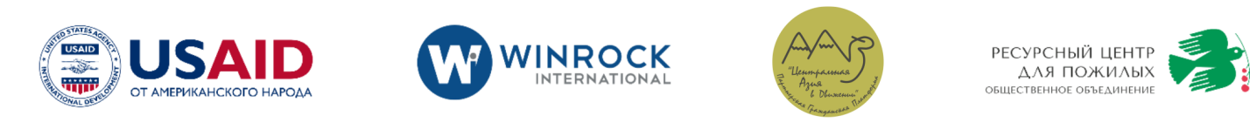

July 2, 2021
MEDIA ADVISORY
Information-Consultation Center launches a new website for migrants.
The Information-Consultation Center of the Department of External Migration under the Ministry of Foreign Affairs of the Kyrgyz Republic (ICC) with the support of USAID “Safe Migration in Central Asia” project implemented by Winrock International, invites representatives of the media community to take part in the presentation of a new website for migrants – www.migrant.kg. (hyperlink will be added)

The presentation will be held on July 2, 2021 in Bishkek, Orion Hotel Bishkek, at 10.00-12.00 at the following address: 21, Erkindik Boulevard.

During the event, speakers will present the features of the new website and speak about the ICC’s services provided to the population.
The new ICC’s website www.migrant.kg provides the following services:
- Check your data independently and online in the list of persons of the Federal Migration Service of the Russian Federation, whom entry into the territory of the Russian Federation is prohibited ("black list");
- Contact the operators of the ICC’s hotline 1899 to obtain the necessary advice on safe migration and assistance in situations of human trafficking through all available channels such as WhatsApp, Telegram, online chat, telephone communication and other messengers;
- Obtain reliable information on legal and safe migration, including information on private employment agencies that have permission to employ citizens abroad;
- Get access to updated information on the procedure for obtaining payment for expenses related to the delivery of bodies of citizens who died abroad back to the Kyrgyz Republic.
The speakers of the presentation are:
- Azizbek Madmarov, Deputy Minister of the Ministry of Foreign Affairs of the Kyrgyz Republic (TBC);
- Noel Bauer, Director of Democracy and Governance office, USAID/Kyrgyz Republic;
- Kubandyk Akmatbekov, Director of the Information-Consultation Center.

For more information please contact: Yulia Salomatina, PR Specialist of Resource Center for the Elderly, tel.:(0555)13-29-37; email: pr.rce.kg@gmail.com.
--------------------------------------
The USAID-funded Safe Migration in Central Asia project is being implemented by Winrock International in four Central Asian countries. It is a five-year project that uses evidence-based practices and cross-border connections to strengthen the mutual accountability and effectiveness of governments, NGOs, and the private sector to prevent trafficking-in-persons, protect survivors, and promote safe migration. The project works in close cooperation with local governments, civil society, and private sector to improve migration practices and prevent exploitation. More information is available on USAID Central Asia’s website: https://www.usaid.gov/central-asia-regional/fact-sheets/safe-migration-central-asia.

